Description of the QR Code Generator Program
The QR Code Generator program is a Python-based application designed to create a Quick Response (QR) code from a user-provided URL. The main purpose of this program is to demonstrate how external Python libraries can be used to convert textual information, such as a website link, into a machine-readable visual format. QR codes are widely used because they allow fast access to digital resources through simple scanning, making this application both practical and relevant to real-world use cases.
The program begins by importing the qrcode library, which provides built-in functionality for generating QR codes and exporting them as image files. A dedicated function named generate_qr_code() is defined to encapsulate the QR code creation process. This function accepts a URL as its input parameter, ensuring that the program remains modular, readable, and easy to maintain. Using a function also follows good coding practices by separating logic into reusable components.
Inside the function, a QR code object is created with specific configuration settings. These settings include the QR code version, a high level of error correction, the size of each box in the QR code, and the width of the border. High error correction is particularly important because it allows the QR code to remain readable even if part of the image is damaged or obscured. The provided URL is then added to the QR code object, and the layout is automatically adjusted to fit the data efficiently.
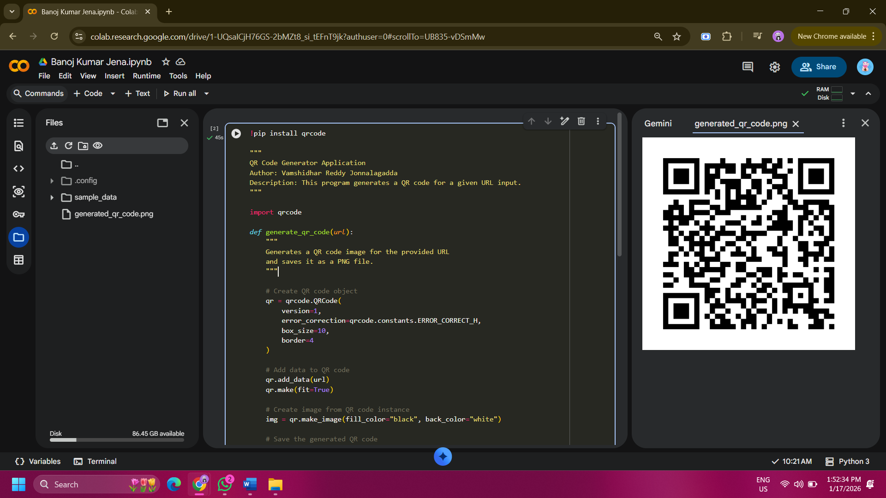

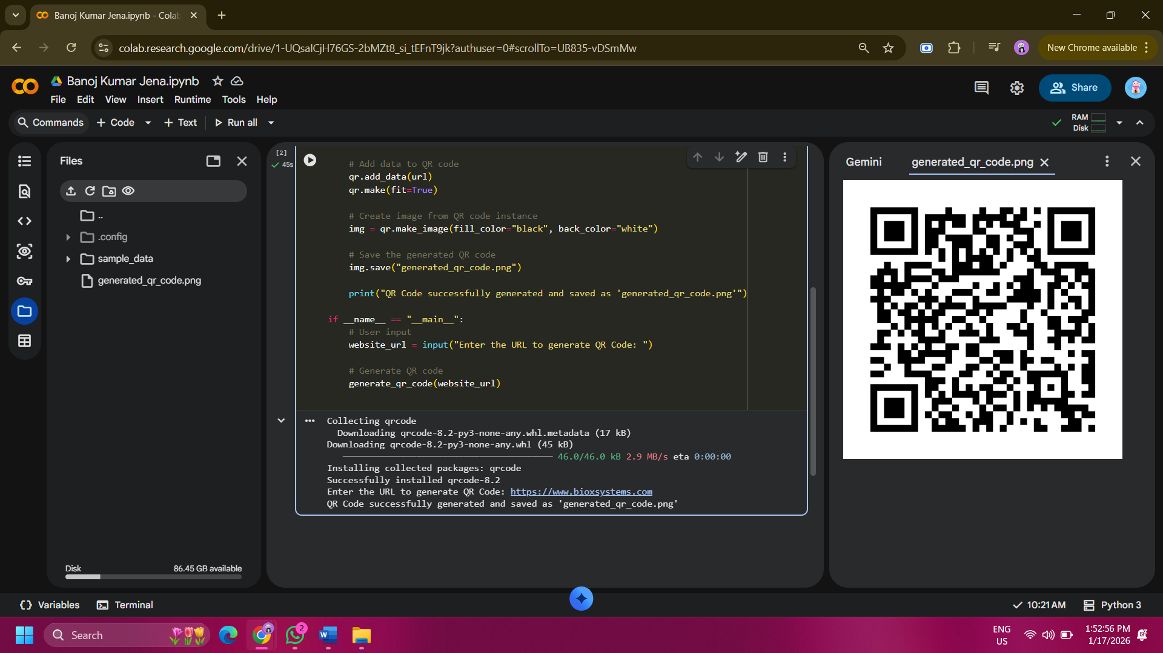
Once the data has been processed, the program generates an image representation of the QR code using a black foreground and white background for maximum contrast and scan accuracy. The generated QR code image is saved locally as a PNG file, making it easy to share, print, or embed in documents or websites. After saving the file, the program displays a confirmation message in the console to inform the user that the QR code has been created successfully.
The execution of the program begins in the main block, where the user is prompted to enter a URL through the console. This input-driven approach allows the program to dynamically generate different QR codes without modifying the source code. Overall, the QR Code Generator program is a simple yet effective application that highlights Python’s ability to automate tasks, integrate third-party libraries, and produce useful real-world outputs in a clean and user-friendly manner.

